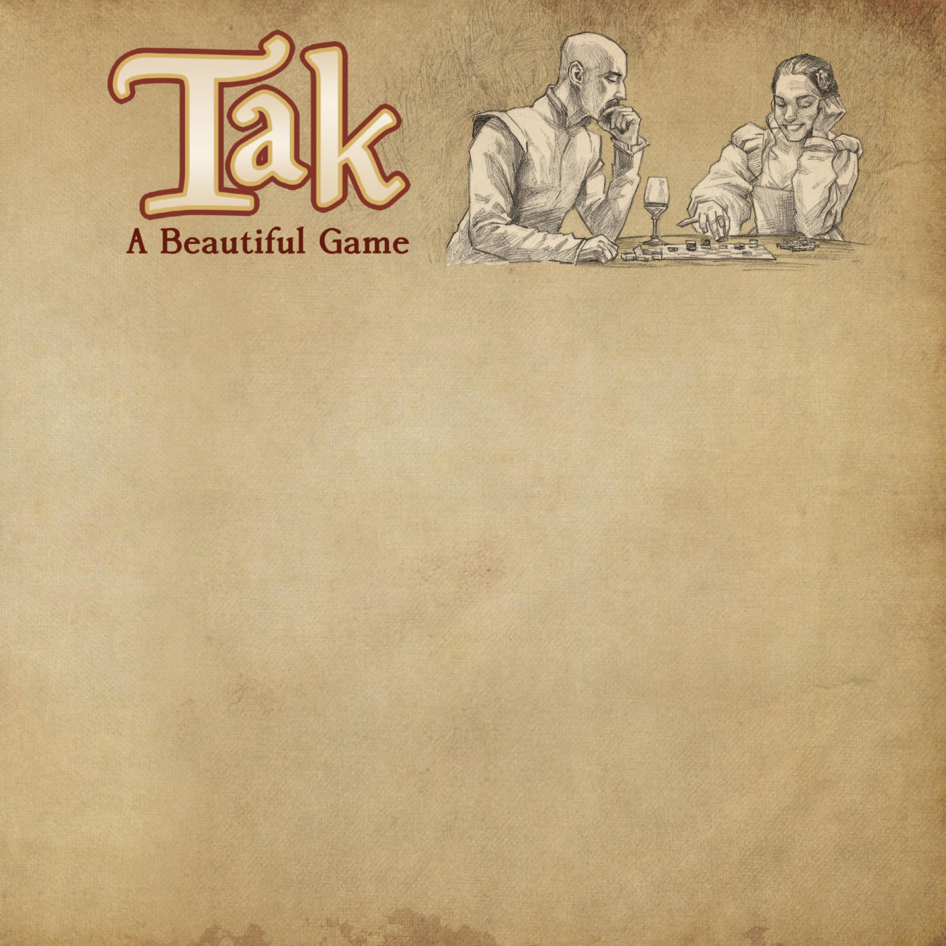™

# 棋盘

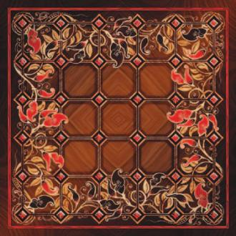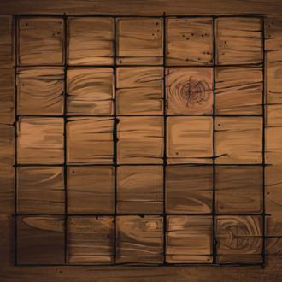

**泰克棋 Tak** 出自 Patrick Rothfuss 的畅销小说《The Wise Man’s Fear》。是小说里 Vintas 宫廷中优雅的双人抽象策略游戏：

*“泰克棋是款很棒的游戏：规则简单，策略复杂。Bredon 爵士轻松地连赢我五局，但我可以很得意地说，他从来没有用同一种方式击败我两次。”*

*-Kvothe*

小说出版后，泰克棋只存在于想象中。现在 Patrick Rothfuss 与 James Ernest 合作把它带到现实世界。

你可以用不同尺寸的棋盘进行游戏，从3x3到6x6甚至更大。

常见的泰克棋棋盘有两种：一种是优雅的**塞拉斯花棋盘 Selas Flower**，另一种是**酒馆棋盘 Tavern**。

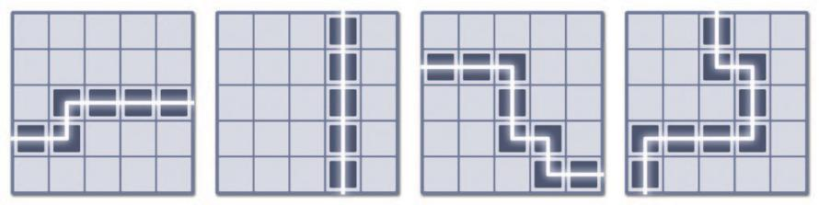

**游戏目标**

泰克棋的目标是构造一条由连续棋子连接棋盘对边的胜利路径。以下是一些示例：

*连接棋盘对边的胜利路径。*

如果有玩家用光棋子，或棋盘已经填满，游戏也会立刻结束。这种情况下，棋盘上平放棋子最多的玩家获胜。详见下文。

*塞拉斯花棋盘 酒馆棋盘*

塞拉斯花棋盘是6x6的“混血”棋盘，你可以用它来进行不同尺寸的游戏。

游玩6x6时，用36个菱形。5x5时，用25个方格。4x4或3x3时，忽略外面的花圈。

酒馆棋盘是简约的5x5设计，但你依然能用网格线交点进行6x6或4x4游戏。

*相连：*泰克棋只有横竖相连。格子不会斜线相连，棋子也不能斜线移动。



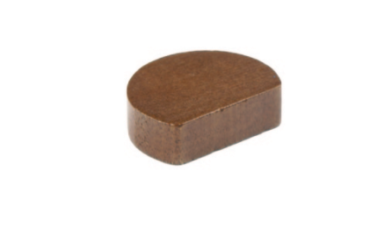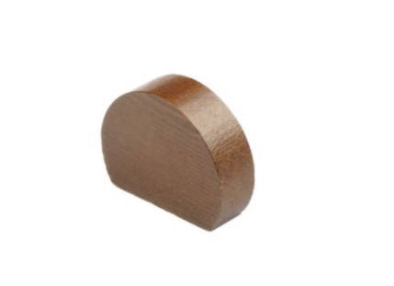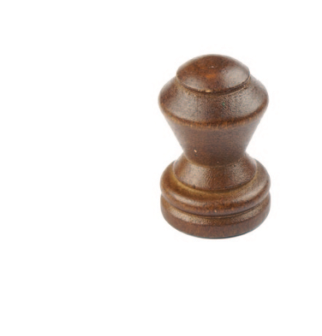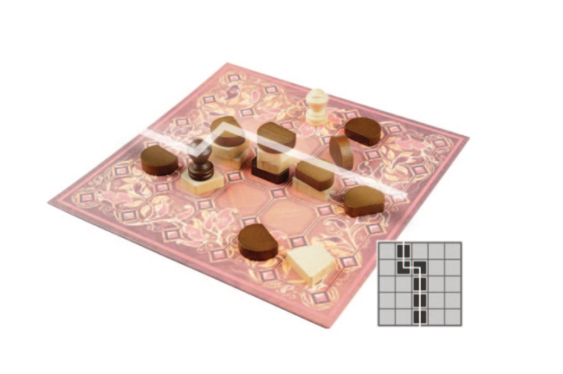

# 棋子

**开局**

开局棋盘清空。检查每位玩家拥有正确数量的棋子。

在多局定胜负的比赛中，第一局随机决定先后手。在这之后，每局交换先后手。

在第一回合，每个玩家放置对手的一枚普通棋子。你可以把棋子放在任意空格，并且必须平放。在这之后，游戏流程正常进行。

*例如，白方先手，白方平放一枚黑方普通棋子，然后黑方平放一枚白方普通棋子，然后白方开始它的正常回合。*

泰克棋有两种棋子：普通棋子与特殊棋子。普通棋子拥有两种状态：平放或竖放。

***平放棋子 Flat Stones：***普通棋子通常平放，如图所示。平放棋子能被堆叠，也算作胜利路径的一部分。

*注释：黑方白方的普通棋子形状可能不一样。只是为了美观。*

***竖放棋子 Standing Stones：***你可以把普通棋子竖放，如图所示。竖放棋子不能被堆叠，但竖放棋子不算作胜利路径的一部分。这使得它们在阻挡上具有优势，所以它们有时被称作“墙”。

**目标**

游戏目标是构造一条由连续棋子连接棋盘对边的胜利路径。胜利路径不一定是直线。格子不能斜线相连。竖放棋子不算作胜利路径的一部分，但特殊棋子算。

在这张图中，黑方连接棋盘对边构造胜利路径获胜。路径中每个格子都有黑方的平放棋子或特殊棋子在最上方。

**其它获胜方法**

***平放获胜 Flat Win：***如果有玩家用光棋子，或棋盘已经填满，那么游戏立刻结束，棋盘上平放棋子最多的玩家获胜。

只计算堆叠最上方的平放棋子，堆叠中被压住的棋子不算数。如果数量相等，这局游戏平局。

***双重路径 Double Road：***如果有玩家在一次行动中同时构造出两位玩家的胜利路径，那么当前行动的玩家获胜。（这种情况可能发生，但十分罕见。）例如，如果白方在一次行动中同时构造出白方胜利路径与黑方胜利路径，那么白方获胜，因为这是白方的回合。

***特殊棋子 Capstones：***特殊棋子兼具竖放棋子与平放棋子的优点：它们算作胜利路径的一部分，同时不能被堆叠。此外，特殊棋子单独移动可以推翻竖放棋子。

推翻竖放棋子时，特殊棋子必须单独移动。你将在移动示例部分了解更多。

**使用多少棋子？**

棋盘尺寸决定棋子数量。每位玩家拥有下列数量：

**棋盘尺寸： 3x3 4x4 5x5 6x6 8x8**

普通棋子： 10 15 21 30 50

特殊棋子： 0 0 1 1 2

***声明“Tak”：****在友好的对局中，当你下一步就能赢时，你通常会说“Tak”警告对手。就像象棋中声明“将军”一样，这并非强制性的。*

# 每个回合

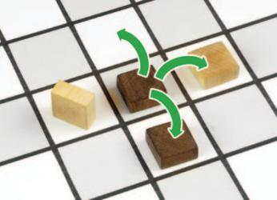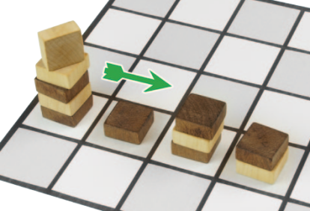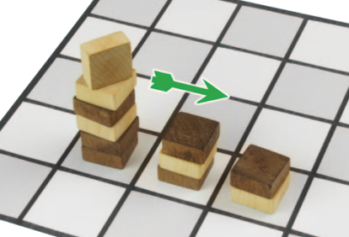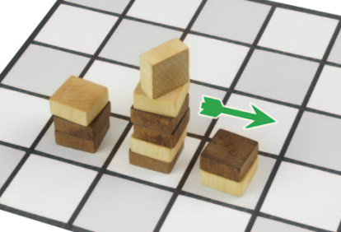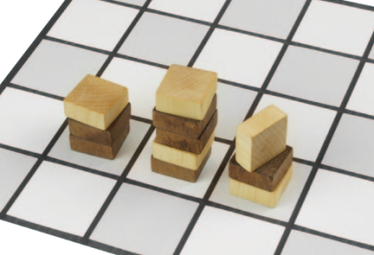

在你的回合，你可以放置一枚棋子到空格中，或是移动一个你控制的堆叠。

***Place:*** You can place a flat stone, a standing stone, or your capstone in any *empty space* on the board. (You never play a piece directly on another one. Stacks only form because of movement.)

If you place your last piece, or if you fill the last space on the board, the game ends immediately.

***Move:*** You can move one or more pieces in a stack that you control. A “stack” of pieces can be any height, including just one piece. “Control” means that your piece is on top.

To move the stack, take any number of pieces off the top, up to the *carry limit* (see below), and move them in a straight line, dropping *at least one piece* off the bottom in each space along the way. The pieces that you drop will cover up any stacks that are already there.

The simplest move is to take one piece and move it one space, as shown in the first movement example. Taller stacks can move farther, dropping pieces as they go.

## Additional Movement Rules

***Carry Limit and Stack Height:*** There is no limit to the height of a stack, but there is a limit to the number of pieces that you can *move*. This “carry limit” is equal to the width of the board, so for example in a 5x5 game, you can carry no more than five pieces. That means if you start with a stack of 7, you must leave at least 2 of those pieces in the starting space.

***Insurmountable Pieces:*** Standing stones and capstones can- not be covered, which means that all the spaces in your path must either be empty or contain flat stones.

***Flattening Walls:*** A capstone can, by itself, move onto a standing stone and flatten it. The capstone may be part of a larger stack that is making a longer move, as long as the final step (crushing the wall) is done by the capstone alone. *Aside from flattening it with a capstone, you cannot lay down a wall.*

# 移动示例

***Moving One Piece:*** You must drop at least one piece in each space as you go, so a single piece can move only one space. The black piece in this diagram can move to three of the four adjacent spaces, as indicated.

If it moves *up*, it moves into an empty space. If it moves *right*, it covers a white piece. If it moves *down*, it covers a black piece. It cannot move *left*, because that space is occupied by a stand- ing stone.

*Note: Standing stones and capstones move by the same rules as flat stones. If this piece were a capstone, it would also have the option to move left, flattening the standing stone.*

***Moving a Taller Stack:***

White controls this stack, with a standing stone on top.

Assuming that this is a 5x5 board, the carry limit is *five*. That means White is allowed to move this entire stack of five pieces, or she could choose to leave some behind.

Moving in a straight line, White must drop *at least one piece in each space*. These pieces come off the bottom of the stack.

In the first space, she leaves two pieces. On the second space, she leaves two pieces again.

The standing stone, by itself, goes into the last space. The end result is shown in the last step.

This single move has given White control of three space*s* that just belonged to Black!



# 得分

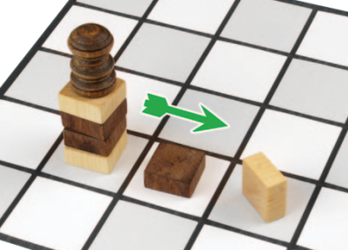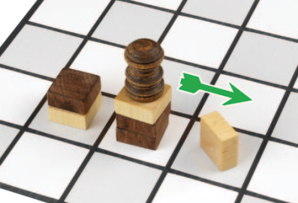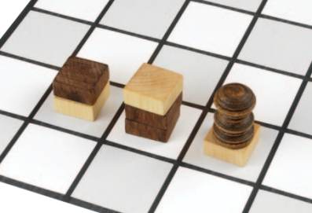

***Moving a Capstone:*** Capstones can move like any other piece. In addition, a capstone can *flatten* a

standing stone, if it does so by itself.

In this example, Black will move his capstone two steps, to flatten White’s standing stone.

In the first step, Black could move up to five of these pieces, but he chooses to leave two pieces behind, and move just three pieces to the next space. (This leaves a black stone in control of the starting space.)

To flatten the standing stone, the capstone must act *alone*. Black leaves the rest of the pieces on the second space, and moves the capstone by itself onto the standing stone.

With this move, Black has flattened White’s standing stone, but has left White in control of the middle stack. This is not perfect for Black, but this type of result is fairly common, as capstones often end up on top of pieces of the opposite color.

Note that capstones can flatten stones of *either color* (not just the opponent’s color).

Because there is a slight advantage for the player who goes first, you should keep score over multiple games.

Your score for winning is equal to the size of the board (for example, 25 points in a 5x5 game), plus the number of pieces that remain unplayed in your reserve.

For example, in a 4x4 game, if you win the game with 4 un- played pieces, you score 20 points. This is 16 points for the board, and 4 for the pieces.

For fairness, take turns going first. In the long run, you will score more points by winning more efficiently.

## Scoring Variants

For a little variety, you can try these scoring variations:

***Downings Rules:*** “Double the Line.” If the winning road is a straight line, the winner scores double points for his pieces.

***Middletown Rules:*** “Double the Cap.” If a player wins without playing her capstone, the piece score is doubled.

***Tarway Rules:*** “Low Road, High Road.” If the winning road is entirely stacks of one piece (a “low road”), then the winner scores double points for her pieces. If the winning road is en- tirely stacks of more than one piece (a “high road”), then the piece score is tripled.

**基础策略**

From the examples, you can see that movement is the key to the game. A tall stack has many options and a long move can seriously change the balance of power.

You can learn the basics of the game by playing a few quick games at 4x4. Because there are no capstones at this level, standing stones are more powerful and you’ll use them for offense as well as defense.

Be careful not to make moves too early; you need to get pieces into play, and not just move the pieces you already have. In the late game, don’t be afraid to “run out the clock” and run out of pieces if you’re ahead on the flats!

*To learn more about Tak, including history, customs, and two more complete games in the same family, look for the* Tak Companion Book*, by James Ernest and Patrick Rothfuss.*

*Tak was created by* ***James Ernest*** *and* ***Patrick Rothfuss****. Playtesters included Boyan Radakovich, Paul Peterson, Rick Fish, Jeff Morrow, Jeff Wilcox, and Joe Kisenwether. This edition was made possible by 12,000 backers on Kickstarter, who contributed more than $1.3M to its success! Boards by Echo Chernik, illustrations by James Ernest and Nate Taylor. Edited by Carol Monahan and Cathy Saxton.* ***Tak: A Beautiful Game*** *is a trademark of Cheapass Games, LLC. Tak was made entirely in the USA.*

*Learn more about Tak at* ***jamesernest.com/games/tak***